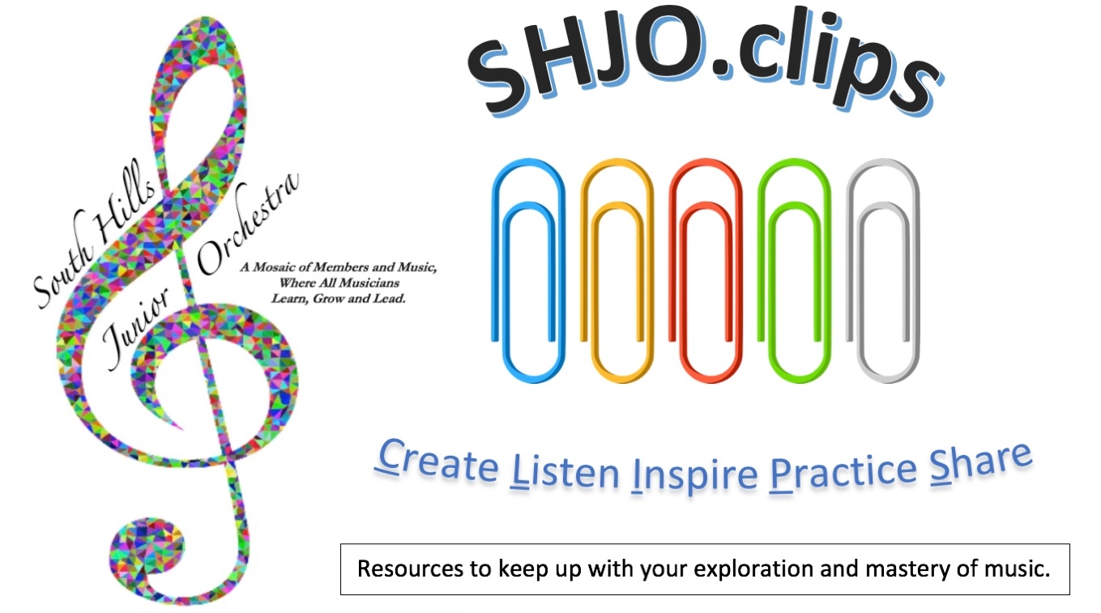
CLIP #45
Intro. to ET⁴ Treasure Box collaborative activity. Continue to create Project 39 videos.
View the new YouTubes links and mini-music-modules below, organize practice time, and work backwards (#44, #43, etc.) for more media!
ET⁴ = Music Terminology
We share new discoveries in expression, time, tonality, timbre, and texture.
The best way to learn something new is to partner with your peers in a joint exploration – a TEAM effort!
The best part of this assignment is that it is hands-on, and you will create a lasting piece of 3D art – an ET⁴ treasure box – something uniquely yours and tangible to show for all your study and work!
Mrs. Fox will outline this SHJOOLA “state-of-the-art” collaboration in our next Synchronous Saturday Session on November 21, 2020. Here is the summary of the schedule/expectations:
- November 21 Introduction to ET⁴
- December 5 Samples/Q&A
- December 12 Boxes due/Breakouts
- December 19 Inventories due

Storm the Castle Tournament Points
- 1 = each ET⁴ box inventory item
- 1 = written reflection/clip journal/ practice diary/listening log
- 5 = participation in ET⁴ breakouts
- 10 = final display/photo of ET⁴ box
- 10 = repertoire class performance
- 20 = Project 39 performance video

20 =
Project 39
Steps to Project 39
Here’s how you can give the “gift of music” and “make a difference!”
- First, if you missed our meeting on 10/9/20, get inspired by Augusto B., and watch his “how-to” video: https://youtu.be/37Xd0N4rfAc followed by this official Project 39 kickoff video: https://youtu.be/PmEHzp-NB7Q
- It’s pretty simple:
  - Just prepare something. It can be a folk song, popular piece, solo from a past lesson, one of the “Classics,” a melodic excerpt from the SHJO or school folder, etc. Think about your audience. Many like things they have heard before, e.g. musicals, TV/movie/ patriotic themes, etc.
  - Record it using any device.
  - Include the title, composer, and description of your work.
  - Upload it as your own YouTube link or just send the file to: shjoonlineacademy@gmail.com

Why do Project 39?
To reach out, cheer up, and entertain others who are restricted due to the pandemic.
Because we care… and if it would make someone feel better or a little less lonely, why wouldn’t we try to share our unique musical talents?

More YouTube Gifts II
Trumpet Bells recorded around the world https://youtu.be/NjCW9EdjvaM
Analyze these in a listening log or journal: What’s your favorite Yorkshire Ballad? https://youtu.be/LkxahXoogLE
https://youtu.be/VROs9jwt0w0
https://youtu.be/hWm0M8P3JCI
https://youtu.be/ZWsLLiYBjmo
Soul Scales for Improvisation https://youtu.be/mjttaiOq-8Q
Conductors “Extras” – Jack Stamp
Left hand cues https://youtu.be/MaYnMSc31tE
Gestures https://youtu.be/NTDSBEGErSM

South Hills Junior Orchestra Music List: Spring & Fall Seasons 2020
TITLE | TROUBLE SPOTS | PRIORITY | TIMES PRACTICED
Disney Magic (F)
Fugue (F)
Grand March from Aida (S)
Land of Liberty (S)
Lord of the Rings #1 (Fellowship of the Ring)
Lord of the Rings #2 (Two Towers)
Lord of the Rings #3 (Return of the King)
The Moldau (F)
Old Scottish Melody (S)
The PA March (F)
La Rejouissance (S)
Rondeau (S)
Russian Choral & Overture (S)
Two Pieces from Iphigenia in Aulis (F)
Yorkshire Ballad (S)

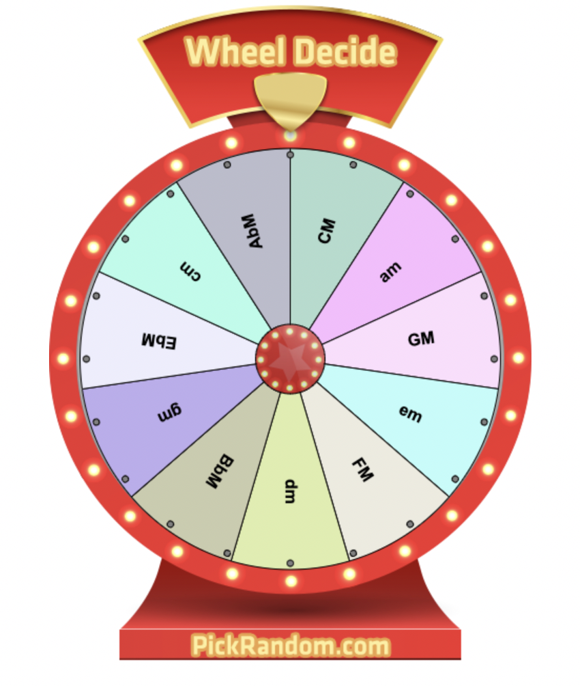
Have you noticed the Mini-Music-Modules?
Check out the latest one on “Spinning Wheels!
http://www.shjo.org/online-academy

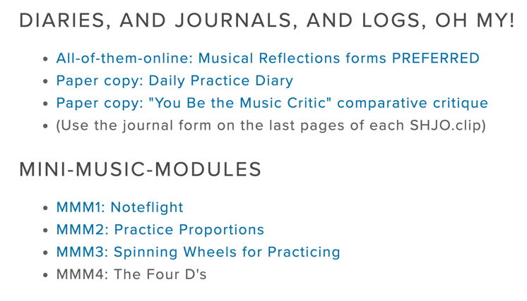

SHJO.clips
Journal of Achievement

# | Activity | P | Dates/Comments/Reflections: What did you accomplish?
35h | Harp Duet from Home
35i | Improv from the Radio
35j | Classical vs. Snob?
35k | Viola Power
36a | Write or Arrange a Duet
36b | Composer Stories 1
36c | Learn Something New
36d | Piano Self-Taught
36e | Practice Tricks
36f | Play Along Trombone Study
36g | Artist Demo and Lesson
36h | Easy Gaming
36i | Compose a Canon
37a | Harmonizing a Melody
37b | Bach Stories II
37c | Something New Vol. 2
37d | Practicing Efficiently
37e | Even Tubas Have Etudes
37f | Playing Jazzy Melodically
37g | Finger Speed Exercises
37h | Atypical Arrangements
37i | Noteflight Transcribing
38a | Conductors’ Colloquium
38b | Grieg’s Speedway
38c | World’s Largest
38d | Trumpet’s Highest Note
38e | Levels of Orchestra Music
38f | Sounds Bad?
38g | Beethoven Story
39 | Project 39 (may be repeated as often as you like)
40 | YouTube Inspirations (per link and reflection)
41 | YouTubes to Peruse
42 | YouTube of the Week: Gift to Brass Players
43 | YouTube Gifts of the Week
44 | Practicing/Gaming & More YouTube Gifts
45 | More YouTube Gifts II
Your Name (Print and Signature)
Date of This Submission
How many SHJO.clip reflections did you do this submission?

All clip journal entries, practice diaries, and listening logs can now be submitted for credit online using this Google form: https://forms.gle/C556wEf2xBJJG6kKA or you can email a copy of your reflections saved as an attachment (please include your name and date in the file name) to shjoonlineacademy@gmail.com

