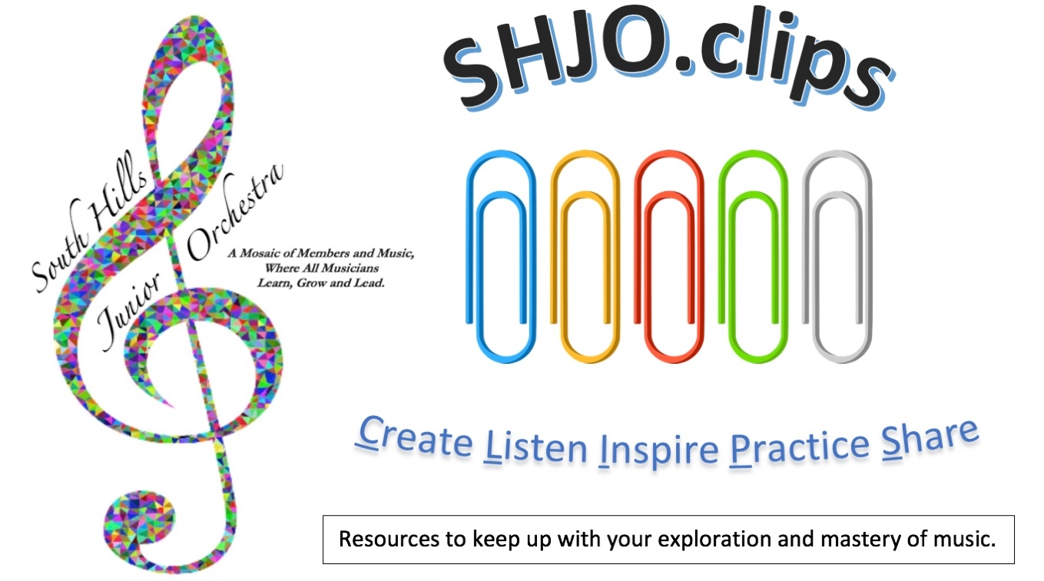
CLIP #44
Project 39 should be your #1 goal! Have you done one? (SHJOOLA schedule p. 4)
View the YouTubes links below, organize your practice priorities, & work backwards (#43, #42, etc.) to discover more media!
Practicing & Gaming
A focus on what you need while making it “fun!”
Formulating written practice goals and check-off lists are the keys to success! As we demonstrated in the 11/7/20 soundtrack practice, the first task is to identify your needs, what are the hard passages, and set a few priorities to manage your prep time. After you post the problem areas, then it is time to chart your progress. Finally, you can add the element of chance in spotlighting which sections or pieces you will cover on a given day (and once done, eliminating these tasks from the agenda until you finish all of the goals).
Here is the recommended process:
- Download one of the files of the SHJO music to-do list. (Pick your favorite file format. The PDF has to be printed in order to be able to handwrite your goals on it.)
- In the second column, define the areas in the music you need to learn. These could be measure #’s or rehearsal letters of your most challenging spots.
- Use a randomizing game app to select the day’s focus:
- https://pickrandom.com/random-wheel/?custom_data=One,Two,Three,Four,Five,Six,Seven,Eight,Nine,Ten
- https://www.random.org/dice/?num=1
- https://www.random.org/lists/
- https://pickerwheel.com/

Project 39
Steps to Project 39
Here’s how you can give the “gift of music” and “make a difference!”
- First, if you missed our meeting on 10/9/20, get inspired by Augusto B., and watch his “how-to” video: https://youtu.be/37Xd0N4rfAc followed by this official Project 39 kickoff video: https://youtu.be/PmEHzp-NB7Q
- It’s pretty simple:
  - Just prepare something. It can be a folk song, popular piece, solo from a past lesson, one of the “Classics,” a melodic excerpt from the SHJO or school folder, etc. Think about your audience. Many like things they have heard before, e.g. musicals, TV/movie/ patriotic themes, etc.
  - Record it using any device.
  - Include the title, composer, and description of your work.
  - Upload it to your own YouTube channel and send the link or the file to: shjoonlineacademy@gmail.com

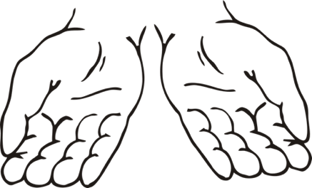

Why do Project 39?
To reach out, cheer up, and entertain others who are restricted due to the pandemic.
Because we care… and if it would make someone feel better or a little less lonely, why wouldn’t we try to share our unique musical talents?

More YouTube Gifts
5 minutes of improvisation on the oboe https://youtu.be/mJe6tZYcT2I
The blues scale for any instrument https://youtu.be/RpObAWZ0SKM
Fiddle backup for 1, 4, and 5 chords https://youtu.be/4zKkQT5RxMY
Movie themes (w/music) for brass quintet https://youtu.be/TyEznH6JayE
What is an octobass? https://youtu.be/k1N4UA5y5kE
3 minutes of Bernstein on “development” https://youtu.be/2jRdXx9yanw

South Hills Junior Orchestra Music List: Spring & Fall Seasons 2020
TITLE | TROUBLE SPOTS | PRIORITY | TIMES PRACTICED
Disney Magic (F)
Fugue (F)
Grand March from Aida (S)
Land of Liberty (S)
Lord of the Rings #1 (Fellowship of the Ring)
Lord of the Rings #2 (Two Towers)
Lord of the Rings #3 (Return of the King)
The Moldau (F)
Old Scottish Melody (S)
The PA March (F)
La Rejouissance (S)
Rondeau (S)
Russian Choral & Overture (S)
Two Pieces from Iphigenia in Aulis (F)
Yorkshire Ballad (S)

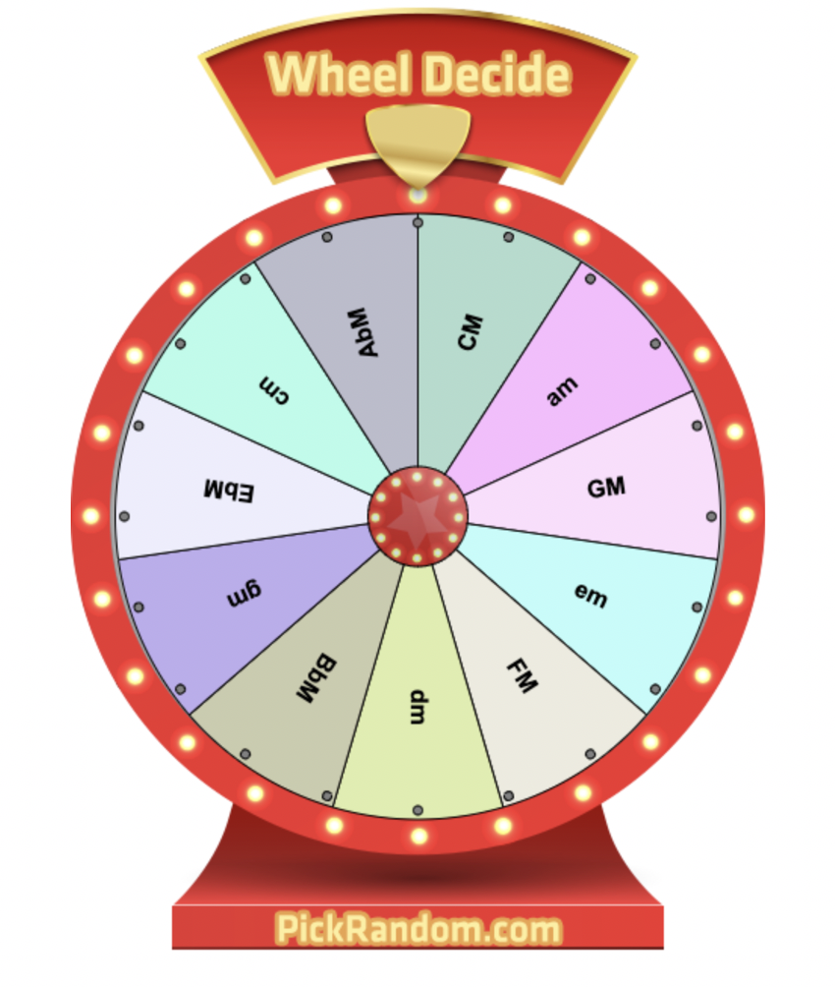

SHJO.clips
Journal of Achievement

# | Activity | P | Dates/Comments/Reflections: What did you accomplish?
35h | Harp Duet from Home
35i | Improv from the Radio
35j | Classical vs. Snob?
35k | Viola Power
36a | Write or Arrange a Duet
36b | Composer Stories 1
36c | Learn Something New
36d | Piano Self-Taught
36e | Practice Tricks
36f | Play Along Trombone Study
36g | Artist Demo and Lesson
36h | Easy Gaming
36i | Compose a Canon
37a | Harmonizing a Melody
37b | Bach Stories II
37c | Something New Vol. 2
37d | Practicing Efficiently
37e | Even Tubas Have Etudes
37f | Playing Jazzy Melodically
37g | Finger Speed Exercises
37h | Atypical Arrangements
37i | Noteflight Transcribing
38a | Conductors’ Colloquium
38b | Grieg’s Speedway
38c | World’s Largest
38d | Trumpet’s Highest Note
38e | Levels of Orchestra Music
38f | Sounds Bad?
38g | Beethoven Story
39 | Project 39 (may be repeated as often as you like)
40 | YouTube Inspirations (per link and reflection)
41 | YouTubes to Peruse
42 | YouTube of the Week: Gift to Brass Players
43 | YouTube Gifts of the Week
44 | Practicing/Gaming & More YouTube Gifts
Your Name (Print and Signature)
Date of This Submission
How many SHJO.clip reflections did you do this submission?

All clip journal entries, practice diaries, and listening logs can now be submitted for credit online using this Google form: https://forms.gle/C556wEf2xBJJG6kKA or you can email a copy of your reflections saved as an attachment (please include your name and date in the file name) to shjoonlineacademy@gmail.com
You may still invite musicians to “try” SHJOOLA for a three-week free-trial period! Ask your friends who play clarinet, sax, brass, etc.

Be sure to contact Managing Director if you have to miss a “Synchronous Saturday” meeting: mdirector@shjo.org.

Weeks #8-11 SHJOOLA Schedule
Date | Time | Synchronous Saturdays
Oct. 31 | 11:00am | Mini-Rehearsal Sectionals
Oct. 31 | Noon | Conducting
Nov. 7 | 11:00am | Mini-Rehearsal Sectionals
Nov. 7 | 11:30am | Fiddle Factory violin 2
Nov. 7 | 11:30am | Soundtracks full orchestra
Nov. 7 | Noon | Conducting
Nov. 7 | 7:00pm | Repertoire Class
Nov. 14 | 11:00am | Mini-Rehearsal Sectionals
Nov. 14 | 11:30am | Conducting
Nov. 21 | 11:00am | Mini-Rehearsal Sectionals
Nov. 21 | 11:45am | Duets/Conductors
Nov. 28 | No SHJOOLA Thanksgiving Week

