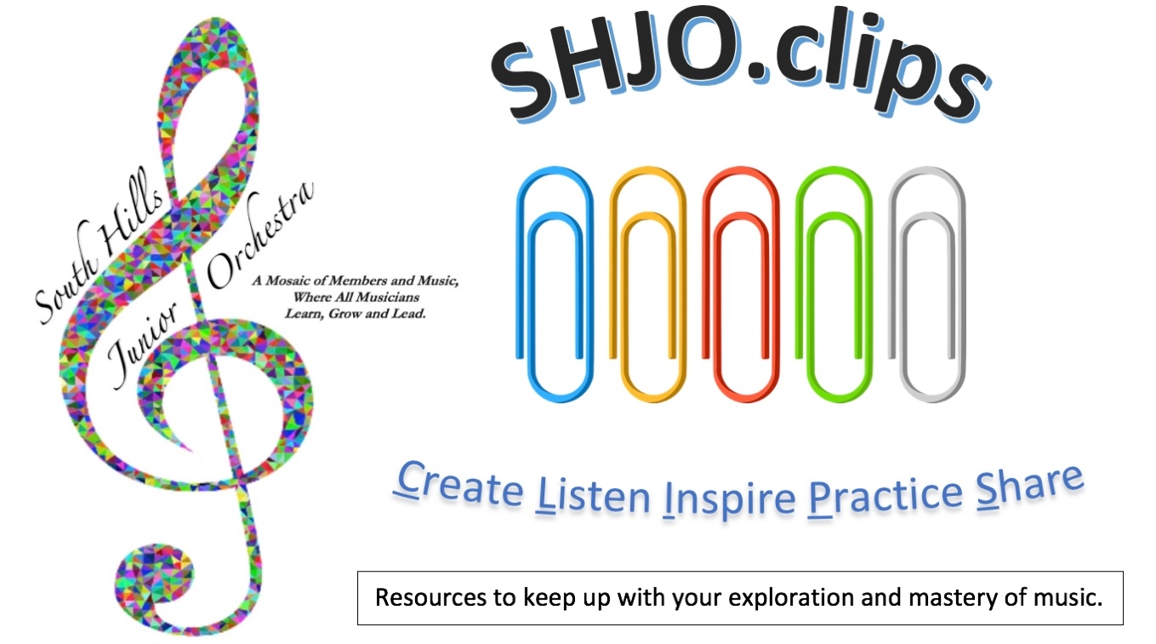
CLIP #40
Our primary focus remains on community service! – Project 39 – see last Clip #39.
Work backwards from #39, then #38, #37, etc. to continue your quest for self-renewal. #40 has new videos to view & reflect!
Steps to Project 39
Here’s how you can give the “gift of music” and “make a difference!”
- First, if you missed our meeting on 10/9/20, get inspired by Augusto B., and watch his “how-to” video: https://youtu.be/37Xd0N4rfAc followed by this official Project 39 kickoff video: https://youtu.be/PmEHzp-NB7Q
- It’s pretty simple:
  - Just prepare something. It can be a folk song, popular piece, solo from a past lesson, one of the “Classics,” a melodic excerpt from the SHJO or school folder, etc. Think about your audience. Many like things they have heard before, e.g. musicals, TV/movie/ patriotic themes, etc.
  - Record it using any device.
  - Include the title, composer, and description of your work.
  - Upload it to your own YouTube channel.
  - Email the link to shjoonlineacademy@gmail.com
YouTube inspirations:
Conductor Collections
Maestros sharing music and the fundamentals of directing. Note the differences between the interpretations (Dudamel & Schwartz) of Beethoven’s 5th.
Leonard Bernstein https://youtu.be/XeP_dsGoImw
Gustavo Dudamel https://youtu.be/22wEhOdfAfA
Gianmaria Griglio
https://www.gianmariagriglio.it/how-to-practice-conducting-at-home
Gerard Schwartz
https://youtu.be/vivT5NaT8Kg
Leonard Slatkin https://www.youtube.com/playlist?list=PL2_S0hFw3zDl47TtV7iYbu-XhiuSrkgaW
Itay Talgam https://youtu.be/R9g3Q-qvtss
Ken Tritle https://youtu.be/diwV2HGKerE

Brass Fanfares
Two versions of Richard Strauss’ Wiener Philharmoniker Fanfare
https://youtu.be/xFvApxrAco4
https://youtu.be/_aim0WNA75c w/music
and Aaron Copland’s Fanfare for the Common Man
https://youtu.be/VEMyj-8I3pw w/music
https://youtu.be/2ryHDsQIYJs

Fiddling on Fire?
Appalachian Fiddler Hillary Klug
https://youtu.be/3FybVapyAts

Project
39

Why do Project 39?
To reach out, cheer up, and entertain others who are restricted due to the pandemic.
Because we care… and if it would make someone feel better or a little less lonely, why wouldn’t we try to share our unique musical talents?

Clip Points?
1 for each journal/log reflection of a link.
10 per repertoire class performance.
20 per Project 39 submission to SHJOOLA.
SHJO.clips
Journal of Achievement

# | Activity | P | Dates/Comments/Reflections: What did you accomplish?
35h | Harp Duet from Home
35i | Improv from the Radio
35j | Classical vs. Snob?
35k | Viola Power
36a | Write or Arrange a Duet
36b | Composer Stories 1
36c | Learn Something New
36d | Piano Self-Taught
36e | Practice Tricks
36f | Play Along Trombone Study
36g | Artist Demo and Lesson
36h | Easy Gaming
36i | Compose a Canon
37a | Harmonizing a Melody
37b | Bach Stories II
37c | Something New Vol. 2
37d | Practicing Efficiently
37e | Even Tubas Have Etudes
37f | Playing Jazzy Melodically
37g | Finger Speed Exercises
37h | Atypical Arrangements
37i | Noteflight Transcribing
38a | Conductors’ Colloquium
38b | Grieg’s Speedway
38c | World’s Largest
38d | Trumpet’s Highest Note
38e | Levels of Orchestra Music
38f | Sounds Bad?
38g | Beethoven Story
39 | Project 39 (may be repeated as often as you like)
40 | YouTube Inspirations (per link and reflection)
Your Name (Print and Signature)
Date of This Submission
How many SHJO.clip reflections did you do this submission?

All clip journal entries, practice diaries, and listening logs can now be submitted for credit online using this Google form: https://forms.gle/C556wEf2xBJJG6kKA or you can email a copy of your reflections saved as an attachment (please include your name and date in the file name) to shjoonlineacademy@gmail.com

